Web Technologies Assessment

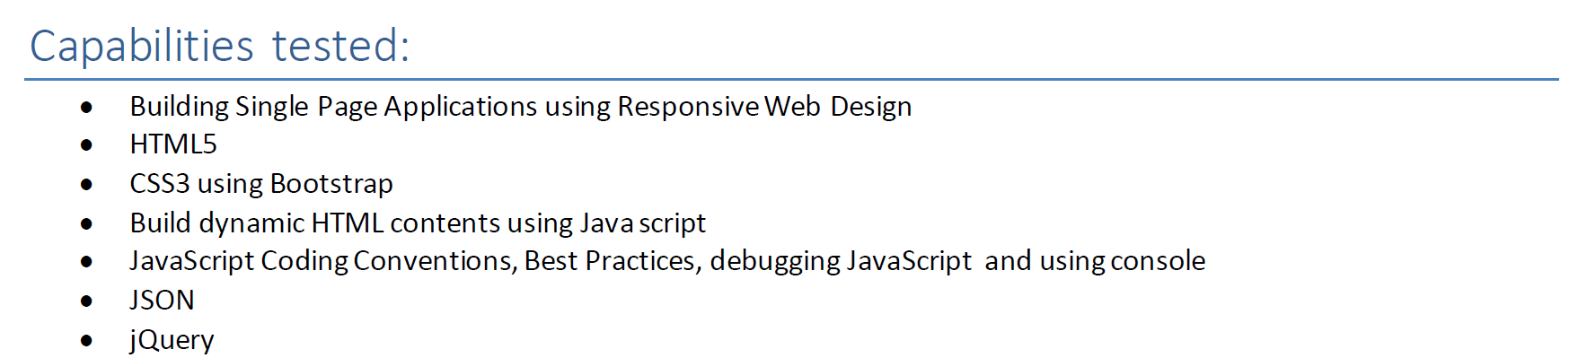

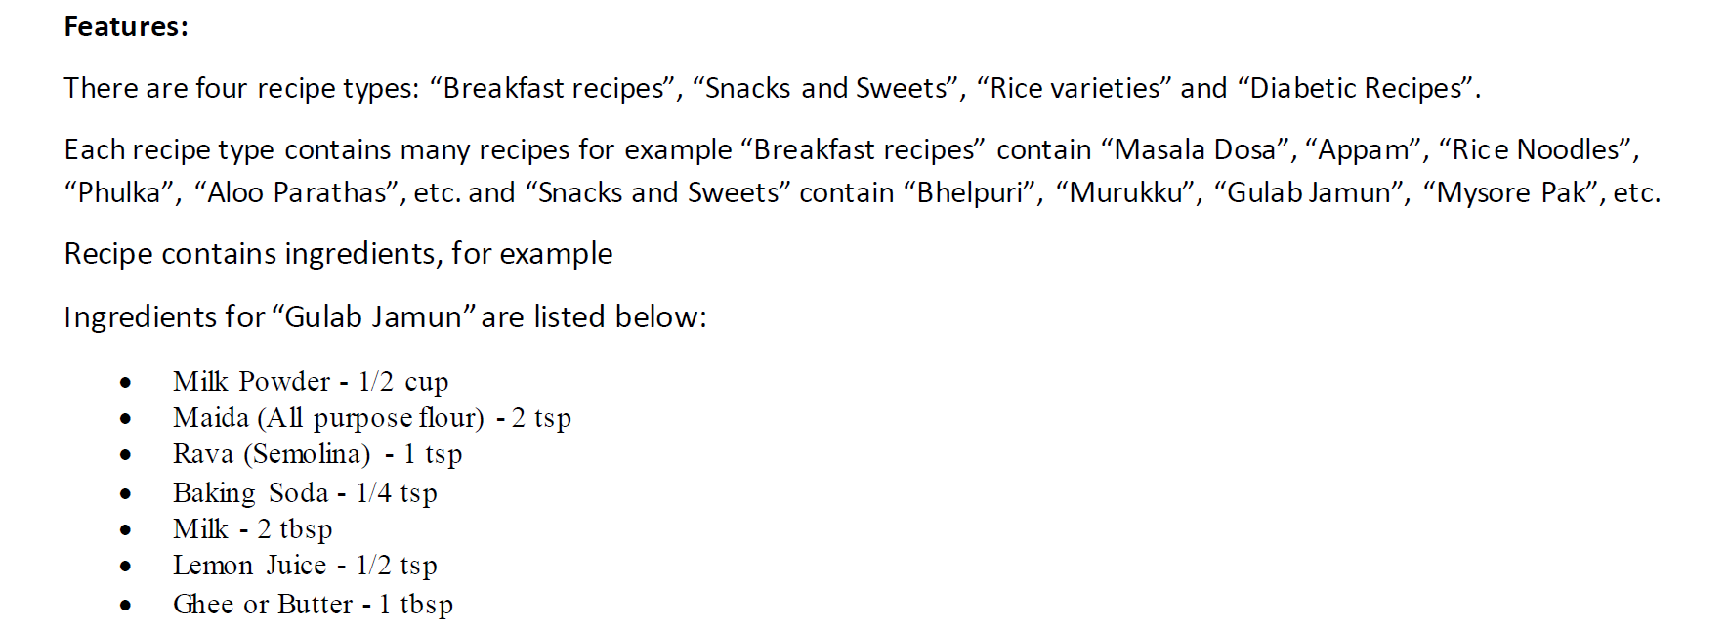

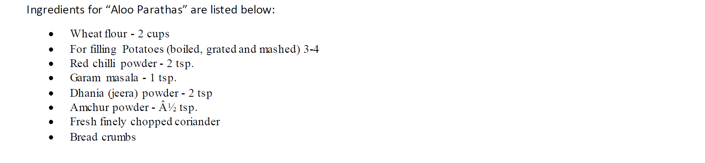

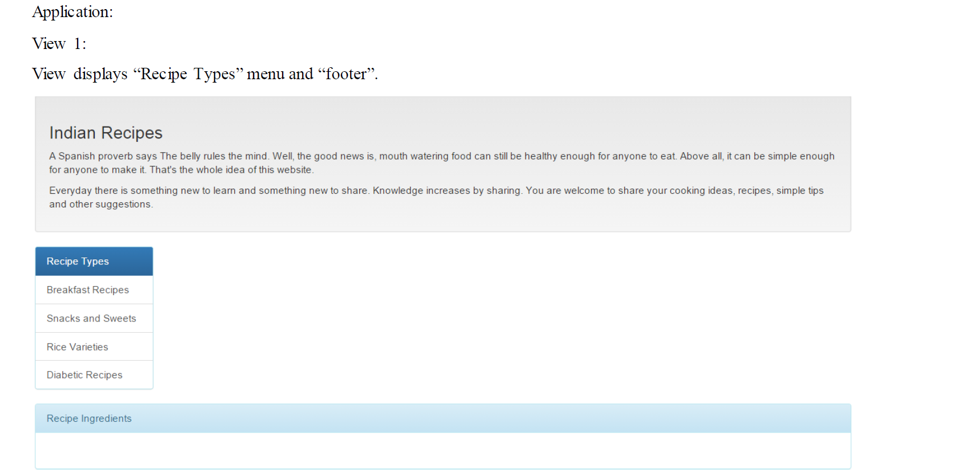

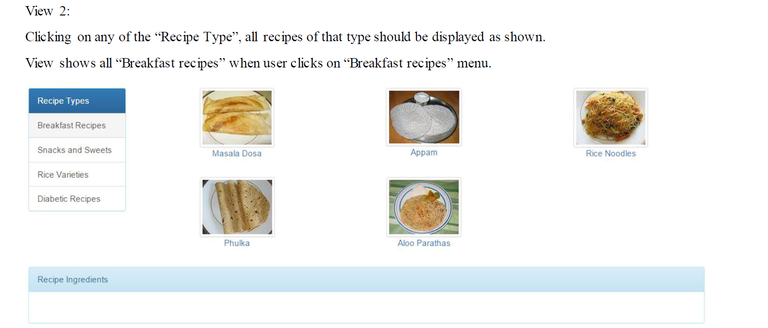

View shows the image the names of the recipes of type “Breakfast recipes”. Each recipe is a hyperlink clicking on that should display the ingredients required to prepare that recipe as shown in view 3.

Note: Images are provided.

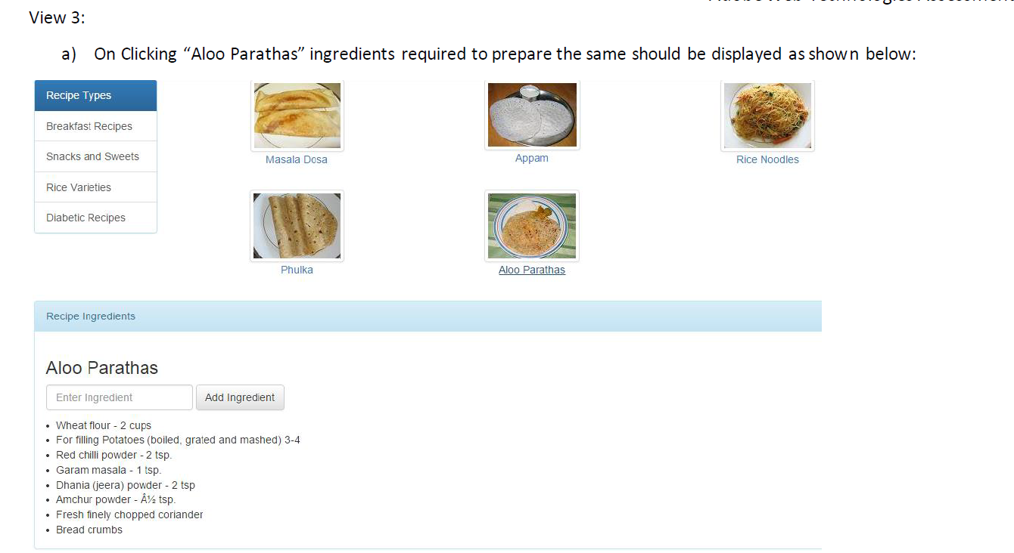

A text input field and “Add Ingredient” button should also be displayed to add new ingredient to the selected recipe. Once ingredient is added it should display the newly added one as last item and also the JSON memory data should be updated. Next time when the recipe is selected previously added ingredients should be displayed.

b) If no ingredients are added to the recipe only text input field and button should be displayed as shown below:

Screen output on clicking “Masala Dosa” hyperlink for which no ingredients are added.

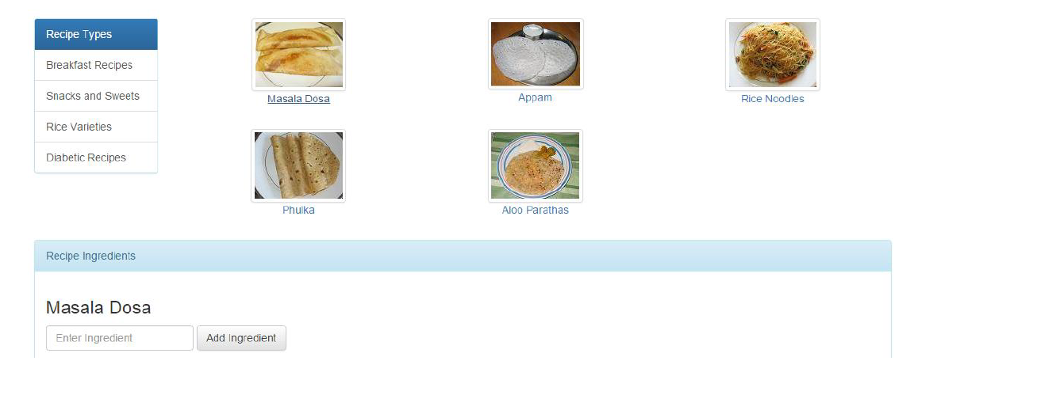

Share the solutions to: banuprakashc@yahoo.co.in